TENDER FORM
“DISPOSED SINU VEHICLE”

The undersigned has carefully inspected the vehicle and the information listed below and hereby offers to submit bid for the vehicle from the Solomon Islands National University and pay the following amounts.

- Description of vehicle: Nissan Hilux (MA 5245)______________ Bid Amount (SBD): __________________________________

- Description of vehicle: Toyota Bus, 15 seater (MB 3970) Bid Amount (SBD): __________________________________

- Description of vehicle : Isuzu 3 Ton (MB 3720) Bid Amount (SBD): __________________________________

- Description of vehicle: Nissan 15, seater Bus (MA 8145)________ Bid Amount (SBD): __________________________________

- Description of vehicle : Toyota Bus, 15 seater Bus (MB 3739)___ Bid Amount (SBD): __________________________________

- Description of vehicle: Isuzu 3 Ton (MB 3718) Bid Amount (SBD):__________________________________

BIDDERS NAME & ADDRESS  ………………………………………………………………………………………….. ………………………………………………………………………………………….. …………………………………………………………………………………………. | BIDDERS CONTACT PHONE: ……………………………………………………………………………………………….  FAX: ……………………………………………………………………………………….. EMAIL: …………………………………………………………………………………….
FORM OF PAYMENT  Options: Cash ( ) Cheque ( ) Others ( )  (Please tick where appropriate) | FINANCIAL CAPABILITY CONFIRMATION  Bank statement ( ) Others ( )  (Please attached photocopy)
RECEIPT NO#: ……………………………………………………………………......  ( Please attached copy of the receipt) | INSPECTION DATE: …………………/…………………………/…………………..  INSPECTION TIME: …………………………………………………………………... (Bidder to fill up)
BIDDER SIGNATURE: …………………………………………………………………  DATE: ………………../……………………/…………………………… | TENDER NO: ……………………………………………………………………………

Vehicle # 1
Model/Type: Nissan Hilux

Vehicle Registration: MA 5245
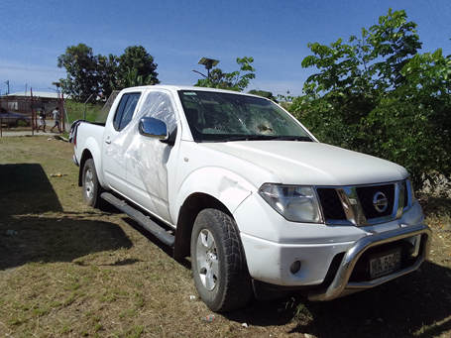

Vehicle # 2.
Model Type: Toyota 15 seater
Vehicle Registration: MB 3970

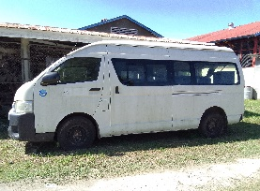

Vehicle # 3.
Model Type: Isuzu 3 Ton
Vehicle Registration: MB 3720 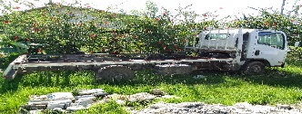

Vehicle # 4

Model Type: Nissan 15 seater Bus
Vehicle Registration: MA 8145

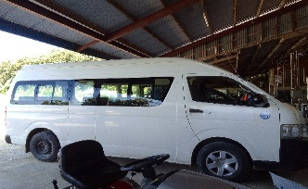

Vehicle # 5
Model: Toyota Bus 15 seater
Vehicle Registration: MB 3739

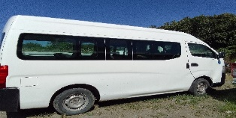

Vehicle # 6
Model: Isuzu 3 Ton
Vehicle Registration: MB 3718
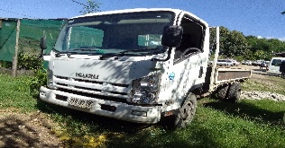

INSTRUCTION TO BIDDERS
- SINU invites bidders to tender for the SINU used vehicles on an “as is “and “where is” basis. The bidder must carefully examine the vehicle and be satisfied regarding the condition of the vehicle.

- SEALED TENDERS must be submitted on the form provided.

- A non-refundable $50.00 Tender fee must be paid into the SINU BSP bank account (9088870419) & deposit slip butt shown to SINU cashier at SINU Finance office to collect a receipt before you submit your tender form. You may also send through email a copy of the deposit slip to email: procurement@sinu.edu.sb to get your receipt.

- When submitting your tender, bid must be enclosed in a sealed envelope clearly marked
“UTB006/22- Vehicle Sale by Tender”.

- The Bids Clearly marked must be returned to the Tender Box located at the Vice Chancellor’s Office and addressed to:

The Chairman
University Tender Board
Solomon Islands National University
Attention: UTB Secretary

- The vehicle is available for viewing at SINU Kukum Campus between 10am to 4:00 pm week days from 9th June 2022 till the closing date. Contact Elizabeth Fatai/Wendy Afu on phone +677 42600/7135420 or email procurement@sinu.edu.sb to arrange for inspection.

- Bidding closes at 4:00 pm on Friday 17th June 2022.

- Late tenders will not be considered and the University Tender Board is not bound to accept the highest or any tender and reserves the right to reject all tenders and to evaluate them in any manner it deems fit.

- Any attempt by a bidder to influence the outcome in their favor will result in automatic disqualification.

- The successful bidders will be required to pay the offered price in full payment to the SINU Bank Account, get a receipt from SINU Cashier and produce copy of the SINU Finance Receipt to the Director Properties and Facilities before they can remove the vehicle.

- Payment and Removal of Vehicles must be made within two (2) working weeks after the winning bidder receives an award letter from the UTB Secretary.

