Doc. 2
Home<SINU.lib.net< Research Tools<Writing Lab

This document is prepared based on the resources of https://www.easybib.com/. SINU students can use this official site through SINU library web site.

Courtesy:

https://www.apa.org

https://www.easybib.com/

Cite Anything and Everything in APA Format
Get the facts on citing and writing in APA format with our comprehensive guides. Formatting instructions, in-text citation and reference examples, and sample papers provide you with the tools you need to style your paper in APA.

EasyBib Guide to APA Format Papers
In this guide, students and researchers can learn the basics of creating a properly formatted research paper according to APA guidelines.
It includes information on how to conceptualize, outline, and format the basic structure of your paper, as well as practical tips on spelling, abbreviation, punctuation, and more. The guide concludes with a complete sample paper that writers can use to prepare their work for submission.

APA Formatting Basics
- All text should be double-spaced
- Use one-inch margins on all sides
- All paragraphs in the body are indented
- Make sure that the title is centered on the page with your name and school/institution underneath
- Use 12-point font throughout
- All pages should be numbered in the upper right hand corner
- The manual recommends using one space after most punctuation marks
- A shortened version of the title (“running head”) should be placed in the upper left hand corner

1. Information related to writing and organizing your paper:

This section of our guide focuses on proper paper length, how to format headings, spacing, and more! This information can be found in Chapter 2 of the official manual (American Psychological Association, 2020, pp. 29-67).
- Paper and essay categories
- General paper length
- Margin sizes
- Title pages
- Running Heads
- APA Outline
- APA Abstract
- The body of papers
- APA headings and subheadings
- Use of graphics (tables and figures)

1. Categories of papers
Before getting into the nitty-gritty details related to APA research paper format, first determine the type of paper you’re about to embark on creating:
Empirical studies : Empirical studies take data from observations and experiments to generate research reports. It is different from other types of studies in that it isn’t based on theories or ideas, but on actual data.

Literature reviews
These papers analyze another individual’s work or a group of works. The purpose is to gather information about a current issue or problem and to communicate where we are today. It sheds light on issues and attempts to fill those gaps with suggestions for future research and methods.

Theoretical articles
These papers are somewhat similar to a literature reviews in that the author collects, examines, and shares information about a current issue or problem, by using others’ research. It is different from literature reviews in that it attempts to explain or solve a problem by coming up with a new theory. This theory is justified with valid evidence.

Methodological articles
These articles showcase new advances, or modifications to an existing practice, in a scientific method or procedure. The author has data or documentation to prove that their new method, or improvement to a method, is valid. Plenty of evidence is included in this type of article. In addition, the author explains the current method being used in addition to their own findings, in order to allow the reader to understand and modify their own current practices.

Case studies
Case studies present information related an individual, group, or larger set of individuals. These subjects are analyzed for a specific reason and the author reports on the method and conclusions from their study. The author may also make suggestions for future research, create possible theories, and/or determine a solution to a problem.

2. General paper length
Since APA style format is used often in science fields, the belief is “less is more.” Make sure you’re able to get your points across in a clear and brief way. Be direct, clear, and professional. Try not to add fluff and unnecessary details into your paper or writing. This will keep the paper length shorter and more concise.

3. Margin sizes in APA
When it comes to margins, keep them consistent across the left, right, top, and bottom of the page. All four sides should be the same distance from the edge of the paper. It’s recommended to use at least one-inch margins around each side. It’s acceptable to use larger margins, but the margins should never be smaller than an inch.

4. Title pages in APA

The title page, or APA format cover page, is the first page of a paper or essay. Some teachers and professors do not require a title page, but some do. If you’re not sure if you should include one or not, ask your teacher. Some appreciate the page, which clearly displays the writer’s name and the title of the paper.
The APA format title page for student papers includes six main components:
- the title of the APA format paper
- names of all authors
- institutional affiliation
- course number and title
- instructor’s name
- due date
Title pages for professional papers also require a running head; student papers do not.
Some instructors and professional publications also ask for an author’s note. If you’re required or would like to include an author’s note, place it below the institutional affiliation. Examples of information included in an author’s note include an ORCID iD number, a disclosure, and an acknowledgement.

Sample of an APA format title page for a student paper:

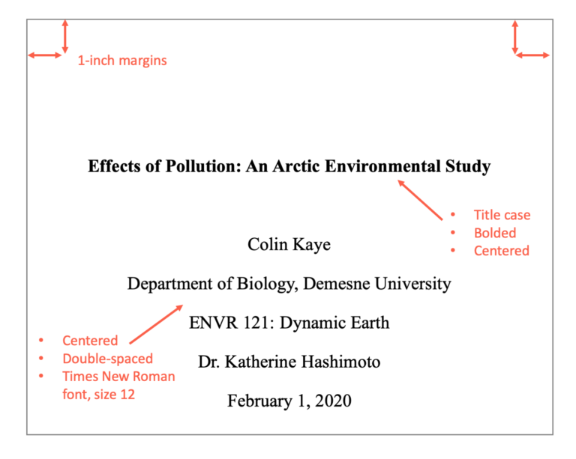

5. Running heads in APA
The 7th edition of the American Psychological Association Publication Manual (p. 37) states that running heads are not required for student papers unless requested by the instructor. Student papers still need a page number included in the upper right-hand corner of every page. The 6th edition required a running head for student papers, so be sure to confirm with your instructor which edition you should follow. Of note, this guide follows the 7th edition.
Running heads are required for professional papers (e.g., manuscripts submitted for publication). Read on for instructions on how to create them.
Are you wondering what a “running head” is? It’s basically a page header at the top of every page. To make this process easier, set your word processor to automatically add these components onto each page. You may want to look for “Header” in the features.
A running head/page header includes two pieces:
- the title of the paper
- page numbers.
Insert page numbers justified to the right-hand side of the APA format paper (do not put p. or pg. in front of the page numbers).
For all pages of the paper, including the APA format title page, include the “TITLE OF YOUR PAPER” justified to the left in capital letters (i.e., the running head). If your full title is long (over 50 characters), the running head title should be a shortened version.
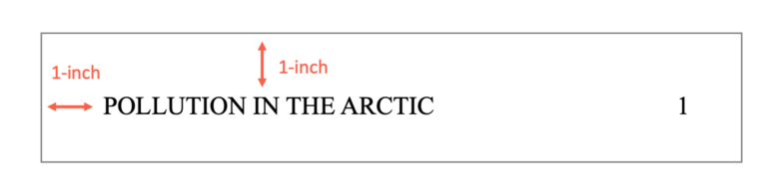

6. Preparing outlines in APA
Outlines are extremely beneficial as they help writers stay organized, determine the scope of the research that needs to be included, and establish headings and subheadings.
There isn’t an official or recommended “APA format for outline” structure. It is up to the writer (if they choose to make use of an outline) to determine how to organize it and the characters to include. Some writers use a mix of roman numerals, numbers, and uppercase and lowercase letters.
Even though there isn’t a required or recommended APA format for an outline, we encourage writers to make use of one. Who wouldn’t want to put together a rough outline of their project? We promise you, an outline will help you stay on track.

7. How to form an abstract in APA
An APA format abstract (p. 38) is a summary of a scholarly article or scientific study. Scholarly articles and studies are rather lengthy documents, and abstracts allow readers to first determine if they’d like to read an article in its entirety or not.
You may come across abstracts while researching a topic. Many databases display abstracts in the search results and often display them before showing the full text of an article or scientific study. It is important to create a high quality abstract that accurately communicates the purpose and goal of your paper, as readers will determine if it is worthy to continue reading or not.
Are you wondering if you need to create an abstract for your assignment? Usually, student papers do not require an abstract. Abstracts are not typically seen in class assignments, and are usually only included when submitting a paper for publication. Unless your teacher or professor asked for it, you probably don’t need to have one for your class assignment.
If you’re planning on submitting your paper to a journal for publication, first check the journal’s website to learn about abstract and APA paper format requirements.
Here are some helpful suggestions to create a dynamic abstract:
- Abstracts are found on their own page, directly after the title or cover page.
- Professional papers only (not student papers): Include the running head on the top of the page.
- On the first line of the page, center the word “Abstract” (but do not include quotation marks).
- On the following line, write a summary of the key points of your research. Your abstract summary is a way to introduce readers to your research topic, the questions that will be answered, the process you took, and any findings or conclusions you drew. Use concise, brief, informative language. You only have a few sentences to share the summary of your entire document, so be direct with your wording.
- This summary should not be indented, but should be double-spaced and less than 250 words.
- If applicable, help researchers find your work in databases by listing keywords from your paper after your summary. To do this, indent and type Keywords: in italics. Then list your keywords that stand out in your research. You can also include keyword strings that you think readers will type into the search box.
- Use an active voice, not a passive voice. When writing with an active voice, the subject performs the action. When writing with a passive voice, the subject receives the action.
  - Active voice: The subjects reacted to the medication.
  - Passive voice: There was a reaction from the subjects taking the medication.
- Instead of evaluating your project in the abstract, simply report what it contains.
- If a large portion of your work includes the extension of someone else’s research, share this in the abstract and include the author’s last name and the year their work was released.

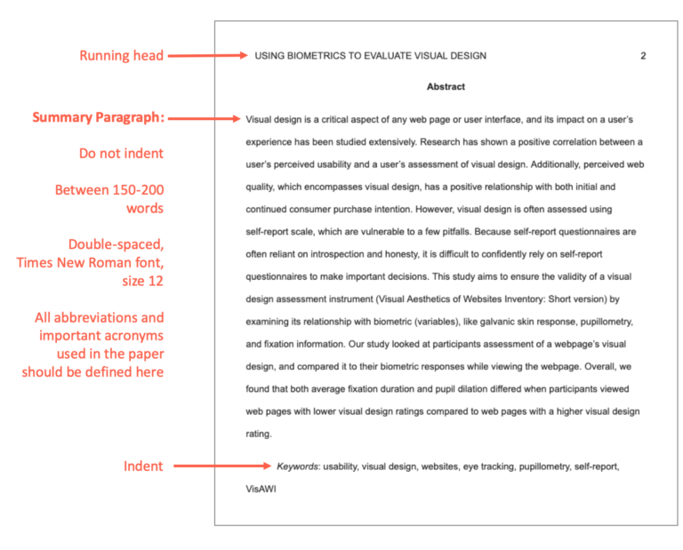

8. The body of an APA paper
On the page after the title page (if a student paper) or the abstract (if a professional paper), begin with the body of the paper.
Most papers follow this format:
- At the top of the page, add the page number in the upper right corner of all pages, including the title page.
- On the next line write the title in bold font and center it. Do not underline or italicize it.
- Begin with the introduction and indent the first line of the paragraph. All paragraphs in the body are indented.

9. Proper usage of headings & subheadings in APA
Headings serve an important purpose in research papers — they organize your paper and make it simple to locate different pieces of information. In addition, headings provide readers with a glimpse to the main idea, or content, they are about to read.
In APA format, there are five levels of headings, each with a different formatting:
- Level 1:
  - This is the title of your paper
  - The title should be centered in the middle of the page
  - The title should be bolded
  - Use uppercase and lowercase letters where necessary (called title capitalization)
- Level 2:
  - Place this heading against the left margin
  - Use bold letters
  - Use uppercase and lowercase letters where necessary
- Level 3:
  - Place this heading against the left side margin
  - Use bold letters
  - Use uppercase and lowercase letters where necessary
  - End the heading with a period
- Level 4:
  - Indented in from the left margin
  - Bolded
  - Use uppercase and lowercase letters where necessary
  - End the heading with a period
- Level 5:
  - Indented
  - Bolded
  - Italicized
  - Use uppercase and lowercase letters where necessary
  - End the heading with a period

Following general formatting rules, all headings are double spaced and there are no extra lines or spaces between sections.

10. Use of graphics (tables and figures) in APA
If you’re looking to jazz up your project with any charts, tables, drawings, or images, there are certain APA format rules (pp. 195-250) to follow.
First and foremost, the only reason why any graphics should be added is to provide the reader with an easier way to see or read information, rather than typing it all out in the text.
Lots of numbers to discuss? Try organizing your information into a chart or table. Pie charts, bar graphs, coordinate planes, and line graphs are just a few ways to show numerical data, relationships between numbers, and many other types of information.
Instead of typing out long, drawn out descriptions, create a drawing or image. Many visual learners would appreciate the ability to look at an image to make sense of information.
Before you go ahead and place that graphic in your paper, here are a few key guidelines:
- All graphics, whether they’re tables, photographs, or drawings must be numbered. The first graphic, labeled as 1, should be the first one mentioned in the text.
  - Follow them in the appropriate numerical order in which they appear in the text of your paper. Example: Figure 1, Figure 2, Table 1, Figure 3.
  - Example: Figure 1, Figure 2, Table 1, Figure 3
- Only use graphics if they will supplement the material in your text. If they reinstate what you already have in your text, then it is not necessary to include a graphic.
- Include enough wording in the graphic so that the reader is able to understand its meaning, even if it is isolated from the corresponding text. However, do not go overboard with adding a ton of wording in your graphic.
- Left align tables and figures.

10.1 Tables:
Is there anything better than seeing a neatly organized data table? We think not! If you have tons of numbers or data to share, consider creating a table instead of typing out a wordy paragraph. Tables are pretty easy to whip up on Google Docs or Microsoft Word.
General format of a table should be:
- Table number
- Title
- Table
- Note

Here are a few pointers to keep in mind:
  - Choose to type out your data OR create a table. As stated above, in APA format, you shouldn’t have the information typed out in your paper and also have a table showing the same exact information. Choose one or the other.
  - If you choose to create a table, discuss it very briefly in the text. Say something along the lines of, “Table 1 displays the amount of money used towards fighting Malaria.” Or, “Stomach cancer rates are displayed in Table 4.”
  - If you’re submitting your project for a class, place your table close to the text where it’s mentioned. If you’re submitting it to be published in a journal, most publishers prefer tables to be placed in the back. If you’re unsure where to place your tables, ask!
- Numbers & Title:
  - Include the table number first and at the top. Table 1 is the first table discussed in the paper. Table 2 is the next table mentioned, and so on. This should be in bold.
  - Add a title under the number. Create a brief, descriptive title. Capitalize the first letter for each important word. Italicize the title and place it under the table number.
- Formatting:
  - Only use horizontal lines.
  - Limit use of cell shading.
  - Keep the font at 12-point size and use single or double spacing. If you use single spacing in one table, make sure all of the others use single spaces as well. Keep it consistent.
  - All headings should be centered.
  - In the first column (called the stub), center the heading, left-align the information underneath it (indent 0.15 inches if info is more than one line).
  - Information in other columns should be centered.
- Note: If you need to further explain something, or include an APA format citation, place it in a note below the table. There are 3 types:
  - General. Information about the whole table.
  - Specific. Information targeted for a specific column, row, or cell.
  - Probability. Explains what certain table symbols mean. For example, asterisks, p values, etc.

10.2 Figures:

Figures represent information in a visual way. They differ from tables in that they are visually appealing. Sure, tables, like the one above, can be visually appealing, but it’s the color, circles, arrows, boxes, or icons included that make a figure a “figure.”
There are many commonly used figures in papers. Examples APA Format:
- Pie charts
- Photographs
- Maps
- Hierarchy charts
- Drawings
General format of a figure is the same as tables. This means each should include:
- Figure number
- Title
- Figure
- Note
Use the same formatting tables use for the number, title, and note.
Here are some pointers to keep in mind when it comes to APA format for figures:
- Only include a figure if it adds value to your paper. If it will truly help with understanding, include it!
- Either include a figure OR write it all out in the text. Do not include the same information twice.
- If a note is added, it should clearly explain the content of the figure. Include any reference information if it’s reproduced or adapted.

10.3 Photographs:

We live in a world where we have tons of photographs available at our fingertips.
Photographs found through Google Images, social media, stock photos made available from subscription sites, and tons of other various online sources make obtaining photographs a breeze. We can even pull out our cell phones, and in just a few seconds, take pictures with our cameras.
Photographs are simple to find, and because of this, many students enjoy using them in their papers.
If you have a photograph you would like to include in your project, here are some guidelines from the American Psychological Association.
- Create a reference for the photograph. Follow the guidelines under the table and figure sections above.
- Do not use color photos? It is recommended to use black and white. Colors can change depending on the reader’s screen resolution. Using black and white ensures the reader will be able to view the image clearly. The only time it is recommended to use color photos is if you’re writing about color-specific things. For example, if you’re discussing the various shades of leaf coloration, you may want to include a few photographs of colorful leaves.
- If there are sections of the photograph that are not related to your work, it is acceptable to crop them out. Cropping is also beneficial in that it helps the reader focus on the main item you’re discussing.
- If you choose to include an image of a person you know, it would be respectful if you ask their permission before automatically including their photo in your paper. Some schools and universities post research papers online and some people prefer that their photos and information stay off the Internet.

Contact SINU.lib.net “Information Kiosk” for further assistance or study package.

